Windows Security Configuration & Evidence Documentation

Purpose
To document selected Windows security configurations using screenshots as evidence and record security observations, impacts, and recommendations.

Scope
This document covers selected Windows security settings, their configuration status, supporting screenshots, and identified security observations.

Document Information
Field | Details
Version | 1.0
Author | Durva Amin
Date | 15 August 2026
Status | Draft

Table of Contents
Purpose 1
Scope 1
Document Information 1
Prerequisites 3
Security Procedure 4
Windows Firewall Configuration Check 4
Screenshots & Evidence 4
Expected Result 5
Security Considerations 6
Security Observations / Findings 7
Finding Status 7
Evidence & Findings Table 8
Recommendations 9
Version History 10

Prerequisites
The following prerequisites are required before performing the security configuration checks documented in this procedure.

- Windows computer
- Administrator access
- Windows Security application
- Internet connection, if required for security updates
- Permission to review and document security settings

Security Procedure

Windows Firewall Configuration Check
This procedure checks the status of Windows Firewall and records the configuration as evidence.

- Open Windows Security from the Start menu.
- Select Firewall & network protection.
- Review the status of the available network profiles.
- Verify whether the firewall is turned On or Off.
- Record the observed status and capture a screenshot as evidence.

Evidence: A screenshot of the Windows Firewall status will be captured and included in the documentation.

Screenshots & Evidence
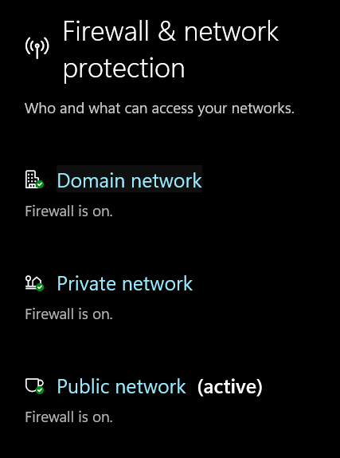

Figure 1: Windows Firewall status showing that the firewall is enabled for Domain, Private, and Public networks.

Expected Result
The Windows Firewall should be enabled for the Domain, Private, and Public network profiles.

Actual Result:
The Windows Firewall is enabled for all three network profiles. The Public network is currently active.

Security Considerations
The Windows Firewall should remain enabled for all network profiles. Firewall settings should only be modified by authorized users, and unnecessary changes to firewall rules should be avoided.

Security Observations / Findings
During the security configuration check, the Windows Firewall was found to be enabled for the Domain, Private, and Public network profiles. No immediate firewall configuration issue was observed.

Finding Status
Status: No issue identified.

Evidence & Findings Table
Observation | Evidence | Impact | Recommendation
Windows Firewall is enabled for Domain, Private, and Public networks. | Screenshot showing Firewall status as On for all three profiles. | No immediate firewall configuration risk was identified. | Continue to keep Windows Firewall enabled and review firewall settings periodically.

Recommendations
Based on the security configuration check, the following recommendations are provided:
- Keep Windows Firewall enabled for Domain, Private, and Public network profiles.
- Review firewall settings periodically to ensure they remain appropriately configured.
- Allow changes to firewall settings only for authorised users.
- Review firewall rules as needed to ensure that unnecessary or insecure rules are not present.

Version History
Version | Date | Author | Changes
1.0 | 15 August 2026 | Durva Amin | Initial Release

Document Status: Draft

